**Project Design Phase**

**Solution Architecture**

|  |  |
| --- | --- |
| Date | 15 February 2025 |
| Team ID | LTVIP2025TMID59486 |
| Project Name | ShopEZ – One-Stop Shop for Online Purchases |
| Maximum Marks | 4 Marks |

**Solution Architecture:**

Solution architecture for **ShopEZ** bridges the gap between the real-world challenges faced by online shoppers and sellers, and the technology required to solve them efficiently. The architecture is designed using modern web technologies and follows a modular, scalable approach, allowing for both current usability and future enhancements. Its goals are to:

* Identify the most suitable full-stack tech solution to handle e-commerce flows effectively.
* Define the structure and behaviour of the platform from both user and admin perspectives.
* Outline core features, user flows, and development phases in a scalable, maintainable way.
* Deliver clear technical specifications for how ShopEZ is designed, developed, and deployed.

**Example - Solution Architecture Diagram:**

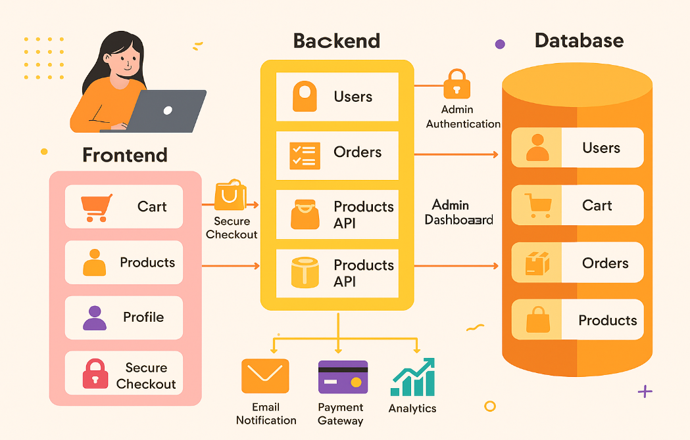

**Reference:** [**https://aws.amazon.com/blogs/industries/voice-applications-in-clinical-research-powered-by-ai-on-aws-part-1-architecture-and-design-considerations/**](https://aws.amazon.com/blogs/industries/voice-applications-in-clinical-research-powered-by-ai-on-aws-part-1-architecture-and-design-considerations/)